FPST 2483 Hands-on Lab Hardy Cross

Student Name: Liu Xinyu

Data Submitted: 2021/5/13

Data of the laboratory: 2021/4/28

Fire Protection and Safety Technology

Oklahoma State University

## Introduction and Objective

The objective of this laboratory unit is to use empirical methods to demonstrate the hydraulic advantages of looped and gridded piping systems and verify the acceptability of methods used to calculate friction loss across loops and grids. Then understand the friction loss reduction due to network system. Finally, practice Hardy-Cross method with problems of multiple loops. All problems are should be solved with Hardy-Cross Method using attached spreadsheets

## Procedure

1. Watch the lab activity at OSU
2. Construct a piping layout that will have a similar appearance with the following graph. 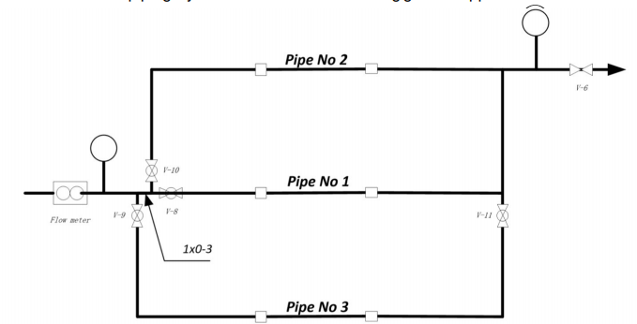
3. Measure and record pipe length, pipe diameters and install the pressure guage beofre the test.
4. Close and open appropriate valve so that all the flow through pipe No.1 and the Q close to 20 gpm, then record the pressure at A and B.
5. Repeat the same procedure on pipe No.2 and pipe No.3
6. Open all the pipes and adjust the rate of flow to 20,30 and 40 gpm, record the pressure at A and B on each test.
7. Open 2 pipes alternatively (1&2, 2&3, 1&3) by shut-off one pipe. Caution, **all pipes cannot be shut-off at the same time**, which buildup the pressure and damage the gauge, and record the pressure on A and B in each trail.
8. Perform calculations to determine how close the calculated values of friction loss are to the measured values. Use the C-factor in your calculations and compensate for the fittings using the equivalent lengths from NFPA 13 that are shown on the following page. Only the flow turns will be considered (included in the pipe length).

## Results and Calculations

#### Length and Arrangement of Pipes

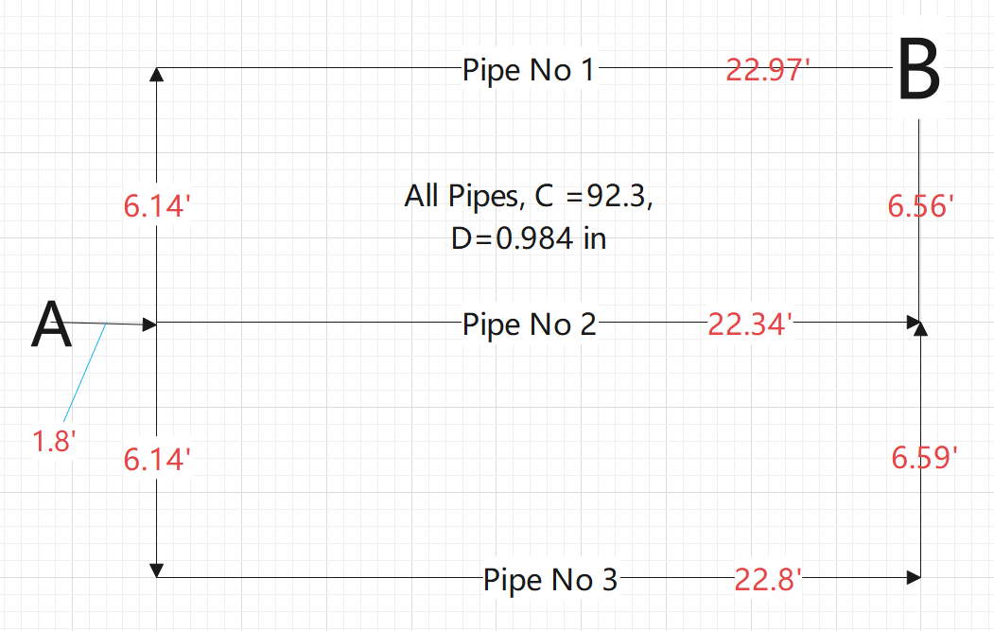

#### Prepare initial flow data for Hardy-Cross

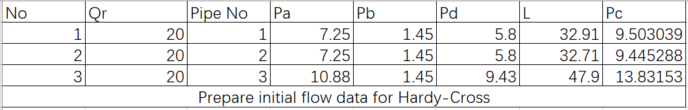

Here the No means the number of trails in the overall hands-on lab. The Qr mean the required rate of flow in each trail. Pipe No means the number of each, which, in this Lab, Pipe 1.2 and 3 are used. Pa means the pressure at point a, while Pb means the pressure at point b. Pd means the difference of pressure in Point a and Point b. L means the equivalent length of each pipe(Using the values in the NFPA 13 table.). Pc means the calculated value according to Hazen-Williams formula.

(Equation 1.1)

Here Pf is the friction loss in psi,

Q is the rate of flow in gpm, and

L is the length of pipe in ft, and

C is the Coefficient of Roughness, and

D is the diameter of pipe in in

For example, I the first row of the table,

=9.50psi Remember that the equivalent length of elbow or tee fitting should be added up in the L

The first estimate might be made with the help of this part.

However, there certainly are some ignorable difference between the actual pressure and the calculated pressure and I will try to explain it in the Summary and Conclusion.

#### Solving one-loop with Hand-Calculation

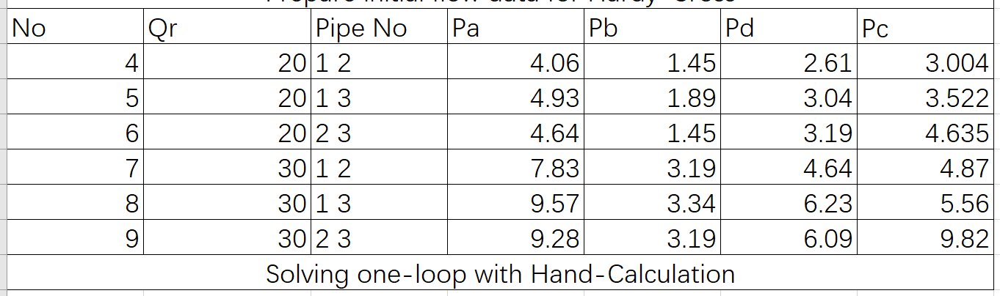

Here No means the number of trails in this lab, Qr is the required rate of flow. In column Pipe No, the co-exist number means that it is a simple loop with two pipes. For example, 1 2 in this column means that in this trail, pipe 1 and pipe 2 are open simultaneously. Pa, Pb and Pd have the same meaning with the last part. The Pc, still the calculated pressure, is solved out by the for two formula and the methodⅡfor simple loops.

(Equation 1.2)

Where Q1 is the flow through path 1, and

QT is the total flow in the loop, and

L1 is the length of path 1, and

L2 is the length of path 2.

However, in order to use this equation 1,2 the diameter and coefficient of roughness must be the same, if not, another equation must be used and the concept of equivalent length must be introduced.

(Equation 1.3)

For example, in trail 4 when pipe1 and pipe2 are open at the same time. Remember that the distance between the A and the tee fitting should be taken into consideration. For Q =20gpm, L = 1.8ft, the friction loss should be 0.52psi, Then comes the distribution of Q in path 1 and path 2. =10.12gpm, the corresponding friction loss should be 1.83psi, so the total friction loss is 2.34 psi. Similar calculation should be applied in the following trails

Then, the rate of flow in this kind of simple loop could be calculated and thus the friction loss can be calculated. Detailed calculation will not be shown here and for different loop, different model are applied taking the length between the distance from Point A to the tee fitting.

#### Solving 2-loops & 3-loops with Hand-calculations

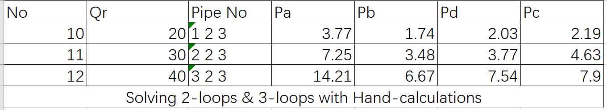

Pipe No 1 2 3 means this is a complex loop of multiple paths for water to flow. In this case, that means all the pipes are allowed to flow. No,Qr, Pa, Pb, Pd have the same meaning in former part. The calculated pressure here are in general calculated in Hardy-Cross Method, a rather complex method that have no space here to talk in details. However, they are solved out through careful and tedious calculations eventually. As the rate of flow is too small here, the 0.05 psi tolerance has been used and The final distribution of Q is as follows. 4 path must be used in the Hardy Cross Method with two real loop and one imaginary loop.

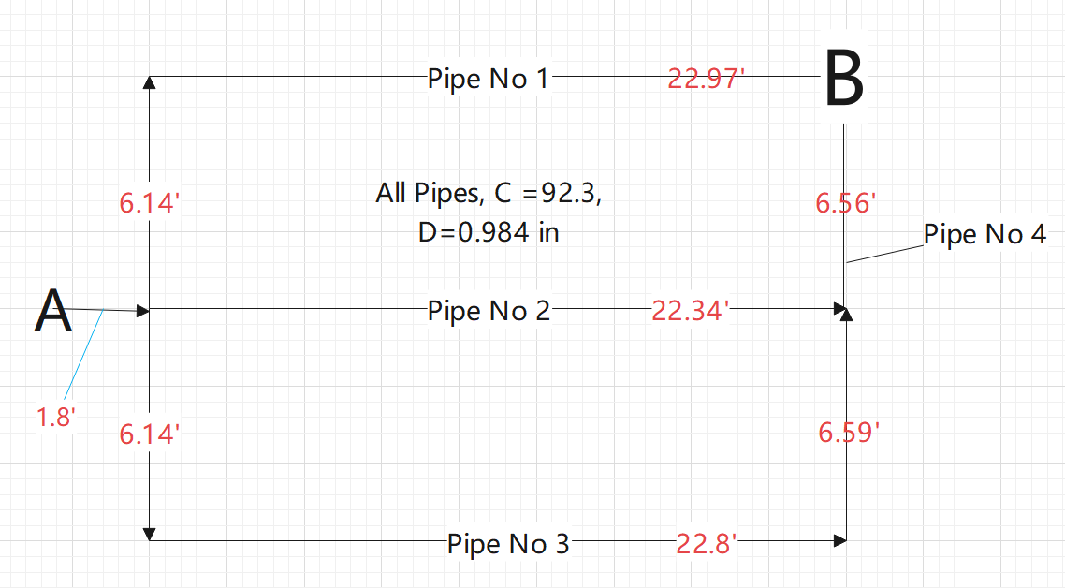

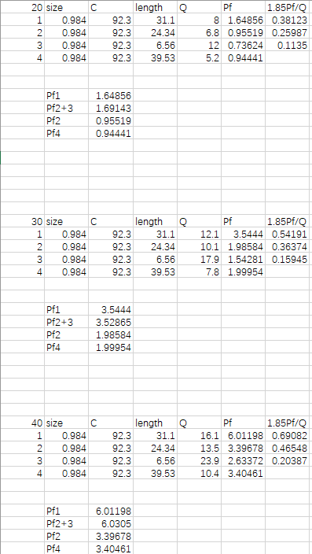

## Summary and Conclusion

However, some significant difference in the first part cannot be ignored. There about 3 to 4 psi difference between actual friction loss and calculated friction loss. This first reason might still be the pressure gauge. The pressure gauge we use in China is SI unit and use Mpa, a unit which is much larger than psi, thus there are easily some errors in reading the gauge. Still, the pressure at the end, namely Pb, is relatively small. In general, a smaller pressure usually not so accurate read. This might also contribute to the error.

Things become a little better concerning the second and third part of the hands-on lab. The difference is usually 0.5 to 1 psi, which should be thoughted acceptable since there are so many distributing factors in this lab environment.

By the way, in general it can be concluded that it seems the pressure in pipe 3 is not normal compared with other two pipes. The difference of height might account for that. As the picture I took in the lab indicated, the elbow in pipe three is not fixed, and the general pipe systems might not in a planar, so 3 or 4 psi ‘s difference might still be reasonable.